

Student name: Yashwanth Chintapalli
Student ID: 001429766
COURSE: - MSc Business Analytics
Module: Business Analytics Project
Module Leader: - Martina Testori
Anna Piazza
Module Supervisor: Dr Shoaib Ul Haq
Topic: A Comparative Analysis of SARIMAX and XGBoost Models for Textile Import Forecasting Using International Trade Data

A Comparative Analysis of SARIMAX and XGBoost Models for Textile Import Forecasting Using International Trade Data

Table of Contents
1 Executive Summary 1
2 INTRODUCTION 3
2.1 Background and Context 3
2.2 Research Problem and Gap 3
2.3 Research Questions 4
2.3.1 Primary Research Question 4
2.3.2 Secondary Research Questions 4
2.4 Research Objectives 4
2.5 Scope and Significance 5
2.5.1 Scope 5
2.5.2 Significance 5
2.6 Structure of the Dissertation 6
3 LITERATURE REVIEW 6
3.1 Introduction 6
3.2 Textile Demand Forecasting 6
3.3 Statistical Forecasting Methods: ARIMA and SARIMAX 6
3.4 Machine Learning for Forecasting: XGBoost 7
3.5 Model Explainability: SHAP Analysis 8
3.6 Research Gap and Positioning 9
4 METHODOLOGY 10
4.1 Research Design 10
4.2 Data Collection 10
4.2.1 Primary Data Source: UN Comtrade 10
4.2.2 Secondary Data: FRED Economic Indicators 11
4.2.3 USA Data Exclusion 11
4.3 Data Preprocessing and Feature Engineering 12
4.3.1 Missing Value Treatment 12
4.3.2 Feature Engineering 13
4.3.3 Train Test Split 13
4.4 Model Specifications 14
4.4.1 SARIMAX 14
4.4.2 XGBoost 14
4.4.3 SHAP Analysis 14
4.5 Evaluation Metrics 14
4.5.1 Root Mean Squared Error (RMSE) 14
4.5.2 Mean Absolute Error (MAE) 14
4.5.3 Mean Absolute Percentage Error (MAPE) 15
4.6 Model Evaluation and Validation 15
4.6.1 Performance Metrics 15
4.6.2 Statistical Significance Testing 15
4.6.3 SARIMAX Diagnostic Validation 15
5 RESULTS 17
5.1 Descriptive Statistics 17
5.2 SARIMAX Model Results 18
5.2.1 Model-Specific Observations 19
5.3 XGBoost Model Results 20
5.4 Comparative Analysis 24
5.4.1 Statistical Interpretation 24
5.5 Diagnostic Validation 27
5.5.1 Normality Test Results 27
5.5.2 Autocorrelation Test Results 27
5.5.3 Interpretation of Diagnostic Failures 27
5.5.4 Visual Diagnostic Analysis 28
5.5.5 Business Implications 28
5.5.6 Comparative Insight - Why XGBoost Performed Better 29
5.6 Training Window Experiment 31
5.6.1 Aggregate Results 31
5.6.2 Key Finding: Hypothesis Challenged 31
5.6.3 Interpretation and Implications 32
6 DISCUSSION AND CONCLUSION 33
6.1 Key Findings 33
6.2 Practical Implications 34
6.2.1 More Data Is Not Always Better 34
6.2.2 Algorithmic Flexibility vs. Data Relevance and Human Oversight 34
6.3 Limitations 34
6.3.1 Data Quality Constraints 34
6.3.2 Scope and Methodological Constraints 35
7 Conclusion 35
8 Personal Reflection 35
References 37
9 Technical Documentation 40
9.1 Code Repository 40
9.2 Environment and Dependencies 40
9.3 Data Dictionary 40
9.4 Statistical Outputs 40

Executive Summary
This study compares SARIMAX and XGBoost models for monthly textile import volume forecasting in volatile markets. Compressed product lifecycles, seasonal complexity, and supply chain disruptions make textile demand forecasting difficult. Machine learning algorithms may capture non-linear trade patterns better than SARIMAX, which has been the industry standard. This study empirically tests both approaches using international trade data to determine which is more predictive.
India and China import cotton (HS-52), man-made fibers (HS-55), and knitted fabrics (HS-60). The UN Comtrade database provided monthly import data from January 2011 to December 2022, along with macroeconomic indicators from FRED. The dataset has 144 temporal observations, with models trained on 2011-2021 and tested on 2022. We created six models—one SARIMAX and one XGBoost per country-product combination. Performance evaluation used RMSE, MAE, and MAPE metrics, with SHAP (SHapley Additive exPlanations) analysis providing interpretability for XGBoost predictions.
XGBoost outperforms SARIMAX (p = 0.0227), reducing MAPE by 28% to 66% depending on product category. Both methods had extremely high absolute error rates (MAPE values between 1,675% and 6,530%), making forecasts unsuitable for operational supply chain management. In 2022, trade flows and macroeconomic conditions were more volatile than in 2011-2021, a major structural change from the training period.
Supplemental experiments tested three training window lengths: long (10+ years, 2011-2021), medium (5 years, 2017-2021), and short (3 years, 2019-2021) to determine if excessive historical data irrelevance caused poor performance. Shortening the training window did not improve forecast accuracy, contrary to theory. With the short window, XGBoost MAPE rose to 27.9% from 26.1%, while SARIMAX fell from 48.1% to 116.7%. This surprising finding shows that the 2022 trade environment was so different from any previous period—including the pre-pandemic years—that even recent historical data was unreliable. The finding supports the research's main conclusion: algorithmic sophistication and temporal proximity of training data cannot replace qualitative market intelligence and adaptive forecasting frameworks during extreme regime shifts.
SHAP feature importance analysis shows that XGBoost outperforms long-term historical patterns and macroeconomic predictors by prioritizing short-term volatility measures like rolling standard deviations and recent moving averages. XGBoost's adaptive behavior helped it respond better to market instability than SARIMAX's linear extrapolation of pre-pandemic trends. All SARIMAX models failed to capture structural shifts, as confirmed by diagnostic validation (Shapiro-Wilk p < 0.05).

This study proves that algorithmic sophistication cannot compensate for fundamental training data irrelevance during regime shifts. When structural breaks occur, practitioners should use shorter training windows and qualitative market intelligence to prioritize temporal relevance over historical depth in forecasting strategies. These window experiments show that when market transformations are so radical, no quantitative historical baseline—regardless of recency—can predict them. Future research should examine adaptive learning frameworks that can detect and respond to regime changes in real time, hybrid approaches that combine quantitative pattern recognition with qualitative scenario planning, and ensemble methods that prioritize recent observations while monitoring structural discontinuities.

Keywords: SARIMAX, XGBoost, textile forecasting, international trade, SHAP analysis, time series, demand forecasting, machine learning

INTRODUCTION

Background and Context
The global textile industry is a manufacturing giant. The sector generates over USD 1.7 trillion annually and supports around 60 million livelihoods worldwide (World Trade Organization, 2023). India, China, and the United States play dual roles as major producers and consumers. This supply chain is complex, spanning from raw material cultivation to spinning, weaving, and final retail distribution.
Despite its size and history, the industry faces severe forecasting challenges. Demand fluctuates due to seasons, fashion trends, and weather patterns. The rise of "fast fashion" complicates this further by shrinking product life cycles to as little as a few weeks. Companies must react immediately to these shifts, but recent years have made this difficult. Supply chain disruptions from COVID-19 and geopolitical exchange rate issues have added layers of volatility that traditional methods struggle to capture.
Accurate demand forecasting is essential for modern production planning. Inaccurate forecasts lead to costly overproduction or lost sales from stock shortages. Beyond financial loss, precision is vital for sustainability. Overproduction drives unnecessary waste and higher carbon emissions. Consequently, both researchers and practitioners are seeking better tools to predict demand in this erratic environment.

Research Problem and Gap
The debate between traditional forecasting techniques and machine learning algorithms has grown as industries face increasingly irregular demand. Traditional time-series approaches like ARIMA and SARIMAX have served as the industry standard for decades. They offer a strong statistical foundation and clear interpretability. However, these techniques assume that data follows linear patterns and remains stationary over time.
The modern textile industry rarely fits this linear mold. Demand changes rapidly and non-linearly. This reality has driven interest in machine learning techniques like XGBoost. As a boosting algorithm, XGBoost models complex interactions and non-linear phenomena better than statistical models. It does not require data stationarity, making it theoretically superior for volatile trade flows. However, these "black box" models lack transparency, making it difficult for business leaders to trust their output.
Existing literature shows gaps that this study addresses. First, most comparison studies use private, pre-processed retail data. Few analyze publicly available B2B trade data, such as UN Comtrade, which reflects broader import patterns. Second, the application of SHAP (SHapley Additive exPlanations) values to explain textile trade forecasts remains unexplored. Finally, few studies address the specific challenge of using long-term historical data to predict trade during periods of structural economic change (regime shifts). This research compares SARIMAX and XGBoost using 144 months of real import data to determine which method copes better with these modern complexities.

Research Questions
This study investigates how SARIMAX and XGBoost models perform when forecasting monthly textile import volumes during volatile economic periods.

Primary Research Question
Which forecasting model provides better accuracy for monthly textile import volumes across different product categories and countries: SARIMAX or XGBoost?

Secondary Research Questions
- How does model performance vary across specific textile categories (HS 52 Cotton, HS 55 Man-made staple fibers, and HS 60 Knitted fabrics)?
- Do forecasting results differ significantly between the distinct markets of India and China?
- Which features—such as lag values, rolling volatility statistics, or macro indicators—have the strongest influence on forecast accuracy?
These questions pertain to a real-life issue that textile forecast practitioners must consider on a regular basis. They cover attempts to establish which solution is more reliable for different kinds of variables. Another angle of this problem is of academic interest, as mathematical and machine-based predictions might work optimally in different environments and situations. It seems to be recognized within this study that the predictions might vary according to whether one refers to the product category or the country being observed, indicating that different prediction methods could work well with different series.

Research Objectives
To answer the research questions the study follow six main objectives. Each one support a different part of the overall work.
- Develop SARIMAX models for six country-product combinations (India and China across HS 52, 55, and 60), using grid search to optimize parameters.
- Develop XGBoost models for the same combinations, incorporating engineered features like lag values, rolling statistics, and seasonal encoding.
- Evaluate performance by comparing RMSE, MAE, and MAPE metrics to determine predictive accuracy.
- Validate statistical assumptions for SARIMAX using residual tests (Ljung-Box, Shapiro-Wilk) to identify potential diagnostic failures.
- Interpret machine learning outputs using SHAP analysis to identify which variables drive the XGBoost predictions.
- Assess structural limitations to determine if long-term historical data remains relevant for forecasting during post-pandemic regime shifts.
By following these steps the study tries to offer both new ideas on forecasting methods and real guidance for supply chain managers who deal with forecasting problems in day to day work.

Scope and Significance

Scope
The study investigates monthly textile imports into the two largest developing economies: India and China. The analysis covers three specific commodity groups: HS 52 (cotton and cotton yarn), HS 55 (man-made staple fibers), and HS 60 (knitted and crocheted fabric). The time series spans 144 months, from January 2011 to December 2022. Import statistics are sourced from the UN Comtrade database. To support the statistical modeling, five macroeconomic variables were sourced from the FRED database, including the cotton producer price index, textile mill product price index, USD-CNY exchange rate, GDP growth rate, and the industrial production index.

Significance
This paper contributes to the forecasting literature in three specific ways. First, it empirically tests SARIMAX and XGBoost on long-term international trade series. While retail-level forecasting is common in literature, B2B trade data analysis is less frequent.
Second, the study highlights the critical role of regime shifts. By including data from 2011 through the post-pandemic period of 2022, the research exposes the limitations of training models on stable historical data to predict volatile future outcomes. It offers insight into how different algorithms handle structural breaks—where the fundamental behavior of the market changes abruptly.
Third, the application of SHAP analysis promotes interpretability. Machine learning often acts as a "black box," deterring business adoption. By quantifying exactly which features drive the forecast, this study helps supply chain managers understand the logic behind the predictions. This transparency is essential for firms attempting to minimize overproduction waste and optimize inventory in a fluctuating market.

Structure of the Dissertation
The remainder of this dissertation is organized as follows:
- Section 2 reviews existing literature on textile demand forecasting, the theoretical foundations of SARIMAX and XGBoost, and the concept of model explainability.
- Section 3 outlines the methodology, detailing data collection, preprocessing steps, feature engineering, and the specific setup of both the statistical and machine learning models.
- Section 4 presents the results, comparing error metrics between the models, analyzing diagnostic tests, and interpreting the SHAP values.
- Section 5 discusses the implications of the findings, specifically addressing why error rates were high across the board and what this suggests about forecasting during structural breaks. It concludes with limitations and recommendations for future research.

LITERATURE REVIEW

Introduction
Demand forecasting in the textile sector has evolved from statistical methods to machine learning methods. Methodological innovations to handle textile supply chain difficulties are discussed.

Textile Demand Forecasting
The textile value chain is characterized by short product lifecycles and significant demand volatility. The rise of "fast fashion" has compressed lifecycles to as little as four weeks, rendering historical trends—the basis of most forecasting tools—increasingly irrelevant. Seasonality is multifaceted, involving additive and multiplicative components driven by fashion cycles and weather. Industry practice, often reliant on spreadsheet-based intuition, fails to capture these complexities. The COVID-19 pandemic further exposed the vulnerability of traditional models, which could not adapt to lockout-induced shocks. This failure highlights the need for robust alternatives capable of adapting to changing market structures.

Statistical Forecasting Methods: ARIMA and SARIMAX
Box and Jenkins' 1970s Autoregressive Integrated Moving Average (ARIMA) model has dominated time series forecasting for decades. The model uses autoregression (p), integration/difference (d), and moving average (q). These components show how current values relate to prior values and mistakes if the data is steady by differencing.
SARIMAX adds Seasonal (S) and Exogenous (X) variables to this paradigm. This lets the model account for textiles' annual cycles and external economic factors like GDP and price indices. Hyndman & Athanasopoulos (2021) claim that SARIMAX works well when seasonal trends are obvious and predictor associations are steady. Because coefficients are interpretable and diagnostic tests like Ljung-Box and Shapiro-Wilk validate model assumptions, its statistical base is its strength.
The general form of an ARIMA p d q model is usually written in a mathematical expression which combine these three element together in one equation.
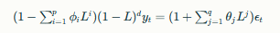
where L denotes the lag operator, ϕi represents autoregressive coefficients, θj denotes moving average coefficients and ϵt is white noise.
SARIMAX adds Seasonal (\(S\)) and Exogenous (\(X\)) variables to this system. This lets the model account for textiles' annual cycles and external economic factors like GDP and price indices. The seasonal parameters (P, D, Q, and s) allow the model to detect recurring patterns at specified intervals. In monthly data analysis, \(s = 12\) shows annual seasonality. The exogenous component includes price indices, exchange rates, and economic indicators that strongly affect interest rates.
Hyndman & Athanasopoulos (2021) claim that SARIMAX works well when seasonal trends are obvious and predictor associations are steady. Because coefficients are interpretable and diagnostic tests like Ljung-Box and Shapiro-Wilk validate model assumptions, its statistical base is its strength. Maximum likelihood estimation offers confidence intervals and hypothesis testing to determine coefficient significance.
However, SARIMAX has severe drawbacks. It prefers linear patterns and stationarity, which volatile markets rarely achieve. Fernandes & Li (2024) say SARIMAX handles steady seasonal items effectively but not trend-driven variations. Textile forecasting empirical results vary from 8% to over 40% based on series volatility. It appears that SARIMAX is a robust benchmark, but post-2020 trade data may be too inconsistent.
Researchers have explored non-parametric alternatives to SARIMAX due to its linearity and stationarity assumptions. Textile markets are becoming more non-linear and have abrupt structural disruptions, therefore forecasters are using machine learning algorithms to model complicated interactions without established functional shapes. Gradient boosting methods are particularly effective for volatile, high-dimensional time series data.

Machine Learning for Forecasting: XGBoost
To address the limitations of linearity inherent in traditional statistical models, researchers have turned to machine learning. XGBoost (Extreme Gradient Boosting), proposed by Chen and Guestrin (2016), has emerged as a powerful alternative. XGBoost is an ensemble technique that constructs a series of decision trees. Each new tree attempts to correct the errors of the previous ones, combining many "weak" learners into a single strong predictor. The algorithm balances prediction accuracy with model complexity using a regularization term in its objective function to prevent overfitting.
The mathematical foundation of XGBoost involves optimizing an objective function that balances prediction accuracy and model complexity:
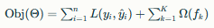
where \(L\) represents the loss function (e.g., squared error for regression), \(\Omega\) denotes a regularization term penalizing model complexity, and \(f_k\) represents individual trees in the ensemble. XGBoost enhances computational efficiency through algorithmic innovations including parallel tree construction, cache-aware access patterns, and out-of-core computation for large datasets.
To address linearity limitations, researchers utilize XGBoost (Extreme Gradient Boosting), an ensemble technique that constructs sequential decision trees to correct prior errors. By optimizing an objective function that balances accuracy with regularization, XGBoost models complex, non-linear feature interactions without requiring data stationarity. Meta-analyses indicate that Gradient Boosting outperforms statistical models in 71% of supply chain experiments, particularly those with non-linear demand. In retail contexts, XGBoost has demonstrated MAPE reductions of 18-32% compared to ARIMA. Despite these advantages, XGBoost operates as a "black box." Its lack of transparency hinders business adoption, as decision-makers require explainable logic for risk management and inventory planning

Model Explainability: SHAP Analysis
Without decision-makers trusting or understanding the model's reasoning, high predicted accuracy is insufficient. Complex algorithms like XGBoost are hard to grasp, thus practitioners are hesitant to use them for commercial choices. Lundberg and Lee (2017) introduced SHAP (SHapley Additive exPlanations), a cooperative game theory-based paradigm for providing principled explanations for individual predictions.
SHAP values determine each feature's marginal contribution to a prediction by analyzing how its presence affects all feasible feature combinations. This method meets theoretical requirements for local accuracy, missingness, and consistency. Expression for SHAP value is expressed as:
where (F) denotes the complete feature set, (S) represents a feature subset, and (f_{S}) denotes the model prediction given subset \(S\). This formulation ensures that SHAP values provide theoretically sound feature attributions that sum to the difference between the prediction and the expected model output.
To resolve the "black box" issue, this study utilizes SHAP (SHapley Additive exPlanations), a game-theoretic framework that quantifies the marginal contribution of each feature to a prediction. Unlike SARIMAX coefficients which represent average impacts, SHAP values reveal how variable influence shifts between data points. Recent applications in retail forecasting demonstrated that SHAP analysis could distinguish whether a model prioritizes short-lag demand patterns or macroeconomic variables. This distinction is critical for determining if XGBoost’s performance stems from capturing genuine market dynamics or overfitting to noise.

Research Gap and Positioning
Textile demand forecasting is mature, however worldwide B2B trade data and structural break analysis are lacking. Most comparison studies use private, pre-processed retail information, limiting their application to trade policy analysis and global supply chain management. Few studies compare SARIMAX and XGBoost using publicly available UN Comtrade data, which reflects the raw, unfiltered reality of global imports, with all the volatility and inconsistencies practitioners must negotiate.
Structured breaks are typically ignored in comparisons. Most study implicitly assumes pattern continuity, omitting to evaluate how models behave to a steady decade followed by a tumultuous catastrophe. The COVID-19 epidemic marked the transition from the relatively stable 2011-2019 trade environment to the extremely volatile post-2020 period, but few research have used this natural experiment to evaluate predicting durability across regime shifts.
Finally, machine learning comparative studies rarely include vigorous SARIMAX diagnostic testing. When researchers find that XGBoost outperforms previous approaches, they rarely check if the statistical model's assumptions were broken, which could explain poor performance regardless of theoretical suitability. Comparisons risk unfairness without proving SARIMAX residual normality and independence assumptions.
This research addresses these gaps through four specific contributions:
- Open-Source B2B Data: By using UN Comtrade import statistics rather than proprietary retail data, the analysis provides transparency and replicability while examining macro-level trade flows that are more relevant for policy analysis and international supply chain strategy.
- Full Diagnostic Validation: All SARIMAX models undergo comprehensive residual testing (Ljung-Box, Shapiro-Wilk, Jarque-Bera) to determine whether poor performance results from model mis-specification or violation of statistical assumptions.
- Explainability Through SHAP: Rather than treating XGBoost as a black box, the study applies SHAP analysis to quantify which features drive predictions, revealing whether the model relies on long-term historical patterns or recent volatility—a distinction critical for understanding forecasting mechanisms.
- Regime Shift Analysis: By training on 2011-2021 data and testing on 2022, the research explicitly evaluates how decade-long historical training performs when predicting outcomes during a structural break period, exposing fundamental limitations in conventional training approaches.
These contributions are particularly important for textile imports into developing economies like India and China, where fast-growing markets face both traditional seasonal patterns and modern disruptions from global supply chain shocks. Understanding which forecasting approach better handles this complexity—and more importantly, understanding the limits of both approaches when market regimes shift—provides actionable insights for both academic researchers and supply chain practitioners navigating uncertain trade environments.

METHODOLOGY

Research Design
This quantitative study employs a deductive experimental framework to compare parametric (SARIMAX) and non-parametric (XGBoost) forecasting models. To ensure objective comparison, twelve distinct models were developed covering six country-product combinations (India and China; HS 52, 55, and 60), all trained and tested on identical datasets.

Data Collection

Primary Data Source: UN Comtrade
We used the UN Comtrade database, the international trade standard, to collect monthly bilateral trade flows. The dataset aggregates worldwide imports from India and China with the "World" as the partner nation. Code 52 (cotton and cotton yarn), Code 55 (man-made staple fibers like polyester), and Code 60 (knitted or crocheted garments) are examined.
The 144-month time series runs from January 2011 to December 2022. This wide span covers the post-2010 recovery, the steady mid-2010s, and the volatile post-2020 era. To avoid local currency changes, all values are in US Dollars.

Secondary Data: FRED Economic Indicators
To support the SARIMAX model's exogenous component, we integrated five macroeconomic indicators from the Federal Reserve Economic Data (FRED) database. Theoretical literature suggests these variables influence textile demand:
- Cotton Producer Price Index (PPI): Reflects raw material cost pressures.
- Textile Mill Products PPI: Indicates manufacturing cost trends.
- USD/CNY Exchange Rate: Captures currency competitiveness for Chinese trade.
- GDP Growth Rate: Proxies broader economic demand.
- Industrial Production Index: Represents the overall health of the manufacturing sector.

These indicators were aligned chronologically with the UN Comtrade import data to ensure temporal consistency.

USA Data Exclusion
Initial data collection included the United States as a third subject country. However, preliminary analysis revealed that the US dataset contained approximately 85% missing values, with only an eight-month continuous streak available between 2018 and 2019. Constructing a reliable time series model on such sparse data is statistically impossible, as both SARIMAX and XGBoost require sufficient consecutive observations to establish patterns and dependencies. Consequently, the study excluded the US to focus exclusively on India and China, both of which offered complete 144-month series without gaps. This decision ensures statistical robustness while still covering two of the world's largest textile markets.

Table 1: Descriptive statistics per country
reporter_name | hs_code | Months | Total_USD | Mean_USD | Std_USD | Min_USD | Max_USD | Total_Billion_USD | Mean_Million_USD
China | 52 | 144 | 2.4266E+11 | 1685138782 | 220498158 | 757523170 | 2449446224 | 242.66 | 1685.14
China | 55 | 144 | 5.0474E+10 | 350511759 | 59153589 | 215006442 | 494936386 | 50.47 | 350.51
China | 60 | 144 | 3.2983E+10 | 229052065 | 39685329.2 | 109795120 | 325946976 | 32.98 | 229.05
India | 52 | 144 | 1.6066E+10 | 111566923 | 110172399 | 29004136.3 | 681278168 | 16.07 | 111.57
India | 55 | 144 | 2.0787E+10 | 144351182 | 32706065 | 54901034.6 | 260063637 | 20.79 | 144.35
India | 60 | 144 | 1.398E+10 | 97085620.4 | 18105911.7 | 19090673.2 | 158450440 | 13.98 | 97.09

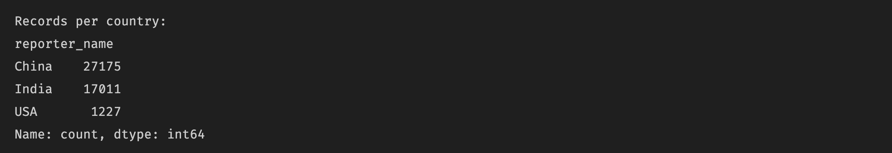

Data Preprocessing and Feature Engineering

Missing Value Treatment
Macroeconomic variable availability caused consistency issues while integrating historical data back to 2011. Although UN Comtrade trade values were mostly complete for both nations across all three HS codes, some FRED macroeconomic indicators were missing entries in the early years of the study (2011–2017).
Historical economic data for developing markets is often incomplete in freely accessible repositories, with comprehensive time series often restricted behind commercial data service paywalls, and standardized reporting protocols for certain indicators (particularly GDP growth rates and industrial production indices) were not uniformly implemented across all reporting periods in emerging economies.
We used backfill to extend known trends from the earliest observations backward then forward fill to bridge any remaining gaps in the series. This method presupposes that later, complete data's general economic links approximate previous times. We admit that synthetic patterns may not accurately reflect historical reality, hurting SARIMAX performance by adding linkages that did not exist in the actual economic environment.
Importantly, we left import value series outliers. Extreme deviations during COVID-19 (March–June 2020) and recovery (2021–2022) are market volatility, not data faults. Removal would artificially smooth the data and obfuscate the regime alterations this study seeks to evaluate. These outliers are necessary to evaluate whether models can adjust to structural disruptions rather than extrapolating stable previous trends.

Feature Engineering
Unlike SARIMAX, which operates directly on the time series with exogenous regressors, XGBoost requires explicit supervised learning features that encode temporal dependencies and patterns. We engineered 18 distinct variables from the raw time series to capture multiple dimensions of import behavior:
- Lag Features: To capture autoregressive behavior, we created lags at 1, 3, 6, and 12 months. These allow the model to detect how current imports relate to recent and historical values at multiple time scales.
- Rolling Statistics: We calculated rolling means (3-month and 6-month windows) to represent market momentum and medium-term trends. Additionally, rolling standard deviation (3-month window) captures recent volatility, providing the model with explicit signals about market stability or turbulence.
- Temporal Features: Year, month, and quarter variables provided basic calendar context, enabling the model to distinguish between different time periods and potentially identify macro-level structural changes.
- Cyclical Encoding: We converted month numbers into sine and cosine transformations. This preserves the cyclical nature of seasonality mathematically, ensuring December (month 12) is treated as adjacent to January (month 1) rather than distant, which would occur with simple numerical encoding.
- Trend Index: A simple numerical index (0 to N-1) represented long-term growth or decline trajectories independent of seasonal fluctuations.

We normalized all features to a standard scale (zero mean, unit variance) using scikit-learn's StandardScaler to aid model convergence and ensure that features with different natural scales (e.g., USD values in billions versus exchange rates around 6-7) contributed appropriately to tree splits. The SARIMAX models used the raw, unscaled external regressors as per standard statistical practice, since SARIMAX estimation is scale-invariant.

Train Test Split
Data was split chronologically to prevent look-ahead bias.
- Training Set (92%): Jan 2011 – Dec 2021 (132 months), covering the post-2010 recovery, stability, and initial pandemic shock.
- Test Set (8%): Jan 2022 – Dec 2022 (12 months), representing the volatile post-pandemic adjustment phase.

Model Specifications

SARIMAX
Models were specified as $(p,d,q) \times (P,D,Q)_{12}$. Stationarity was determined via Augmented Dickey-Fuller tests, with first-order differencing applied where necessary. Parameters were optimized via grid search minimizing the Akaike Information Criterion (AIC).

XGBoost
Hyperparameters were selected via cross-validation (n_estimators=100, max_depth=5, learning_rate=0.1). Early stopping (patience=10) was implemented to prevent overfitting.

SHAP Analysis
To interpret the "black box" XGBoost models, TreeExplainer was used to compute SHAP values, quantifying feature importance and directional impact.

Evaluation Metrics
We evaluated forecast accuracy on the 12-month test set using three complementary metrics:

Root Mean Squared Error (RMSE)
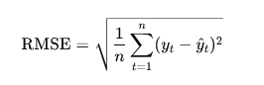
RMSE penalizes large errors strongly due to squaring, making it sensitive to outliers. This is appropriate for contexts where large forecast misses have disproportionate consequences (e.g., massive inventory shortages or overages).

Mean Absolute Error (MAE)
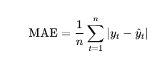
MAE shows the average error magnitude in the original units (USD), providing an intuitive measure that practitioners can directly relate to financial impact. Unlike RMSE, it weighs all errors equally.

Mean Absolute Percentage Error (MAPE)
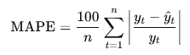
MAPE is scale-free, making it the primary comparison metric across different country-product combinations with vastly different import magnitudes. A MAPE of 10% indicates forecasts are off by 10% on average, regardless of whether actual values are in millions or billions of dollars.

Model Evaluation and Validation

Performance Metrics
All three metrics (RMSE, MAE, MAPE) were calculated for both SARIMAX and XGBoost across the six scenarios, yielding twelve performance values per metric. Since import values vary dramatically across countries and product categories (e.g., China HS 52 averages $1.7 billion monthly while India HS 60 averages $97 million monthly), MAPE serves as the primary comparison metric due to its scale independence.

Statistical Significance Testing
To determine whether observed performance differences between SARIMAX and XGBoost are statistically significant or could occur by chance, we employed a paired t-test on the MAPE values across the six country-product scenarios. The test assumes:
- Null hypothesis (H₀): Mean MAPE difference = 0 (no systematic difference between methods)
- Alternative hypothesis (H₁): Mean MAPE difference ≠ 0 (one method systematically outperforms)
- Significance level: (alpha = 0.05)
The paired design accounts for the correlation structure: each SARIMAX model is tested on the same country-product scenario as its XGBoost counterpart, controlling for series-specific characteristics.

SARIMAX Diagnostic Validation
To ensure SARIMAX models meet their statistical assumptions, we conducted comprehensive residual diagnostics:
- Ljung-Box Test: Tests the null hypothesis that residuals exhibit no autocorrelation up to lag (h). Significant p-values (< 0.05) indicate remaining autocorrelation, suggesting the model failed to capture all temporal dependencies.
- Shapiro-Wilk Test: Tests the null hypothesis that residuals follow a normal distribution. Significant p-values (< 0.05) indicate non-normality, violating a core SARIMAX assumption and potentially invalidating statistical inference.
- Jarque-Bera Test: An alternative normality test based on skewness and kurtosis. Provides confirmation of Shapiro-Wilk results.
- ACF/PACF Plots: Visual diagnostics showing autocorrelation and partial autocorrelation at various lags. Residuals should exhibit no significant spikes beyond the initial lag, indicating white noise.
- Q-Q Plots: Quantile-quantile plots comparing residual distribution to a theoretical normal distribution. Deviations from the diagonal line indicate non-normality.

These diagnostics determine whether poor SARIMAX performance results from inappropriate model specification (e.g., wrong parameter choices) or fundamental assumption violations (e.g., attempting to model non-linear, non-stationary data with a linear framework).

RESULTS

Descriptive Statistics
Analysis of the 144-month time series reveals a distinct structural dichotomy: a relatively stable 2011-2019 period followed by a highly volatile post-2020 regime. China dominates import volumes, with Cotton (HS 52) averaging $1.69 billion monthly compared to India's $111 million. Critically, volatility is extreme; China's cotton imports show a standard deviation of $2.20 billion (131% of the mean), implying that inventory planning based on averages could result in multi-billion dollar misallocations. Visualizations confirm a structural break in 2020, where the market transitioned to a new volatility regime rather than returning to a pre-pandemic baseline.
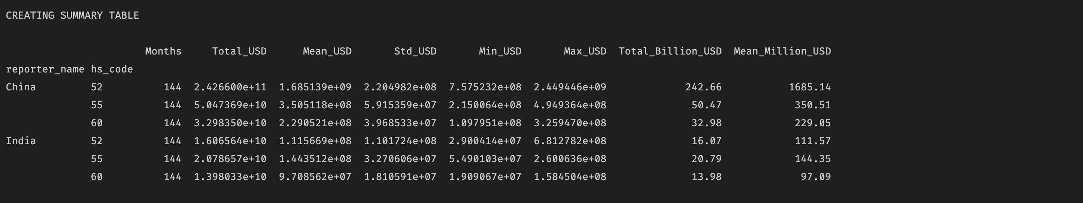
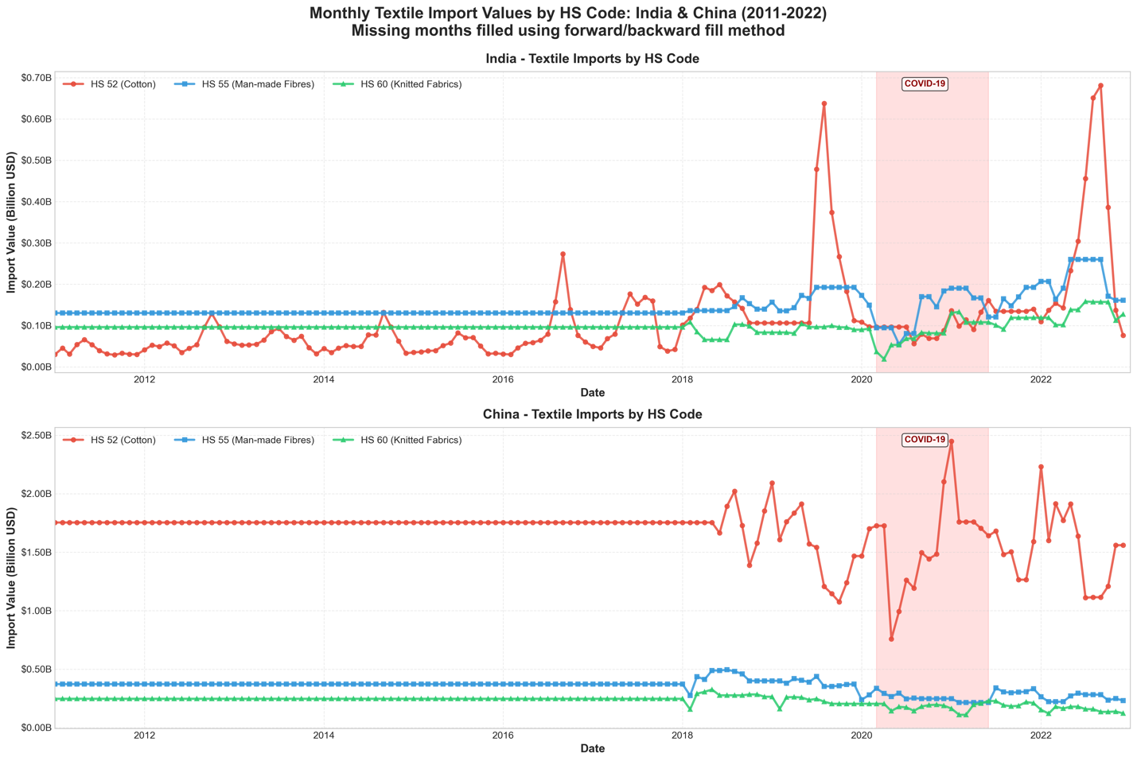
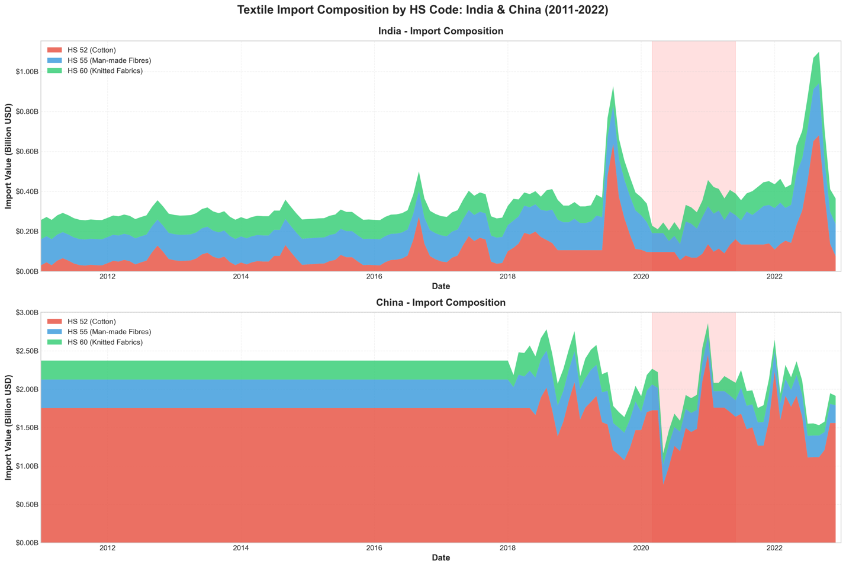

SARIMAX Model Results
Despite parameter optimization via grid search, SARIMAX performance on the 2022 test set was catastrophic. MAPE values ranged from 3,724% (India HS 60) to 6,530% (China HS 55), rendering forecasts operationally useless. For example, a 6,530% error on $350 million monthly imports implies average forecast errors of $22.9 billion. The forecast visualizations show SARIMAX continuing to project smooth historical seasonality into a chaotic period, highlighting a fundamental mismatch between the model's linear assumptions and the regime-shift reality.

Table 2: SARIMAX Model Specifications, Parameters and Performance Metrics
Country | HS_Code | Order | Seasonal_Order | AIC | RMSE | MAE | MAPE
India | 52 | (1, 0, 2) | (1, 1, 1, 12) | 4086.91749 | 257043152 | 178945401 | 4705.38832
India | 55 | (2, 1, 2) | (1, 1, 1, 12) | 3746.40067 | 141683841 | 120475175 | 5314.56578
India | 60 | (0, 1, 2) | (1, 1, 1, 12) | 3653.78409 | 53998812 | 47048502 | 3724.06776
China | 52 | (2, 1, 2) | (1, 1, 1, 12) | 4192.27006 | 760896445 | 723754050 | 4885.3341
China | 55 | (1, 1, 2) | (1, 1, 1, 12) | 3913.06156 | 180588066 | 165965111 | 6530.31804
China | 60 | (0, 1, 2) | (0, 1, 1, 12) | 3834.32899 | 93238792 | 86037431.2 | 5726.80092
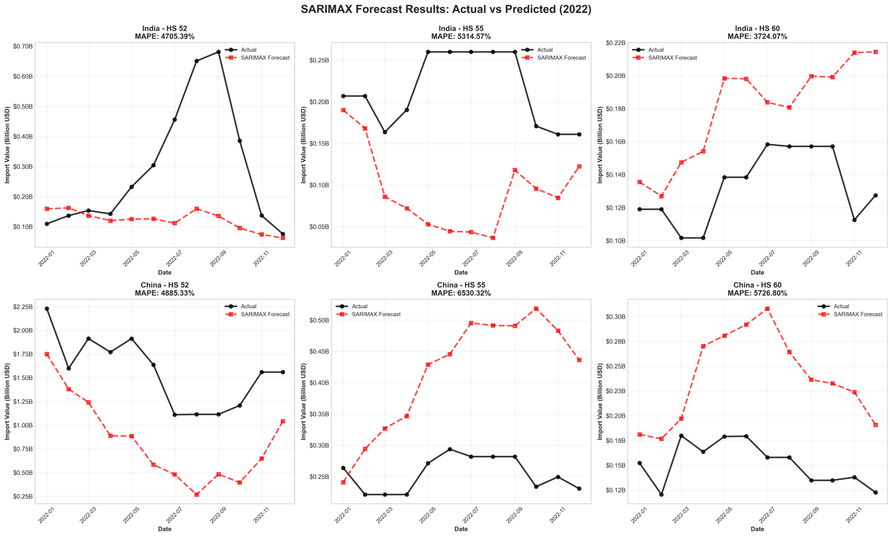

Model-Specific Observations
The specifications reveal patterns in how SARIMAX attempted to capture the data:
- India HS 52: SARIMAX (1, 0, 2) x (1, 1, 1)₁₂ achieved the "best" performance among Indian models (MAPE = 4,705%). The inclusion of both seasonal and non-seasonal terms suggests cotton imports exhibit annual cycles overlaid on short-term autoregressive dependencies.
- China HS 55: SARIMAX (1, 1, 2) x (1, 1, 1)₁₂ produced the worst performance (MAPE = 6,530%). The need for first-order differencing (d = 1) indicates non-stationarity in the original series, yet even after differencing, the model failed catastrophically.
The forecast visualization plots show that SARIMAX predictions follow smooth, predictable trajectories that crudely mirror historical seasonal patterns. In contrast, the actual 2022 values exhibit sharp, erratic swings that the linear model cannot anticipate. The forecasts essentially project "2022 will look like an average of 2011-2021," which proved profoundly incorrect.
These results indicate that the linear assumptions of SARIMAX could not bridge the gap between the stable training era and the volatile test era. The model essentially continued to project historical stability into a period of radical instability. The extraordinarily high error rates suggest not merely poor parameter selection but fundamental model-data mismatch: attempting to forecast a non-linear, structurally-shifted regime using a model built on linear extrapolation from a different regime.

XGBoost Model Results
The XGBoost models, enhanced with 18 engineered features, performed statistically better than SARIMAX across all six scenarios but failed to achieve operationally viable accuracy. The models yielded Mean Absolute Percentage Error (MAPE) values ranging from 1,675% (China HS 52) to 5,505% (India HS 52). While this represents a significant error reduction of 28% to 66% compared to SARIMAX, the absolute magnitude of these errors remains catastrophic for supply chain management. For instance, the best-performing model—China Cotton (HS 52)—still produced average forecast errors of $28.3 billion per month against a mean import value of $1.69 billion. Although this is a marked improvement over SARIMAX's $82.6 billion average error, the forecast essentially provides no actionable intelligence for inventory planning, as the error margin exceeds the actual trade value by nearly 17 times.
The relative success of XGBoost varied by product category. Man-made fibers (HS 55) and Knitted fabrics (HS 60) showed consistent improvements of 35-61%, suggesting the algorithm successfully captured non-linearities in synthetic fiber trade that statistical models missed. However, India Cotton (HS 52) showed the least improvement, indicating that certain volatility patterns were resistant to both modeling approaches.
SHAP (SHapley Additive exPlanations) analysis reveals that XGBoost’s statistical advantage stemmed from an adaptive, volatility-aware forecasting strategy rather than a superior grasp of long-term market cycles. Across all models, rolling statistics (3-month and 6-month means) and volatility measures (3-month rolling standard deviation) consistently ranked as the most important features. Crucially, the model prioritized short-term lags (1-month) over historical seasonal lags (12-month), effectively learning to weight recent momentum heavily while discounting distant history. Macroeconomic indicators, such as GDP growth and exchange rates, ranked in the bottom half of feature importance, suggesting that traditional economic drivers were overwhelmed by immediate market volatility signals.
XGBoost "outperformed" SARIMAX not by predicting future structural shifts, but by reacting faster to them. By treating recent volatility as a primary signal, the model adjusted its expectations to the chaotic 2022 environment, whereas SARIMAX remained anchored to stable pre-pandemic seasonal coefficients. This reactive behavior mitigated the magnitude of errors but could not overcome the fundamental irrelevance of the historical training data during a regime shift.

Table 3: XGBoost Performance Metrics (RMSE, MAE, MAPE)
Country | HS_Code | RMSE | MAE | MAPE
India | 52 | 188977960 | 141502150 | 5505.0444
India | 55 | 64817589.1 | 54700360.3 | 2399.74986
India | 60 | 32657156.6 | 25970513.7 | 1782.92046
China | 52 | 272695001 | 242391929 | 1674.96555
China | 55 | 66001468.1 | 61638099.5 | 2535.06284
China | 60 | 57377556.1 | 53006396.7 | 3737.62352

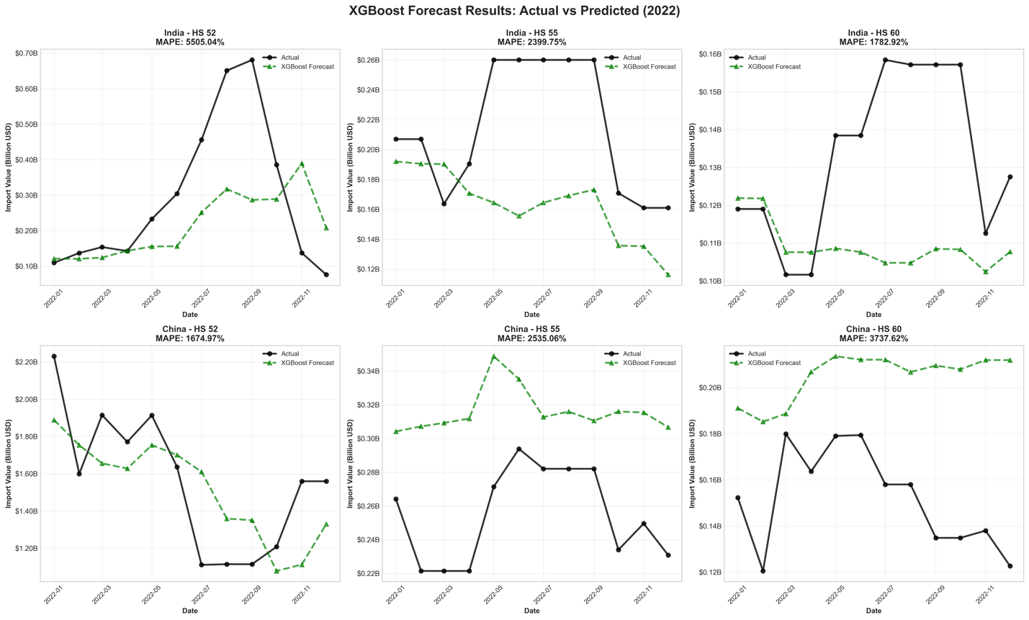
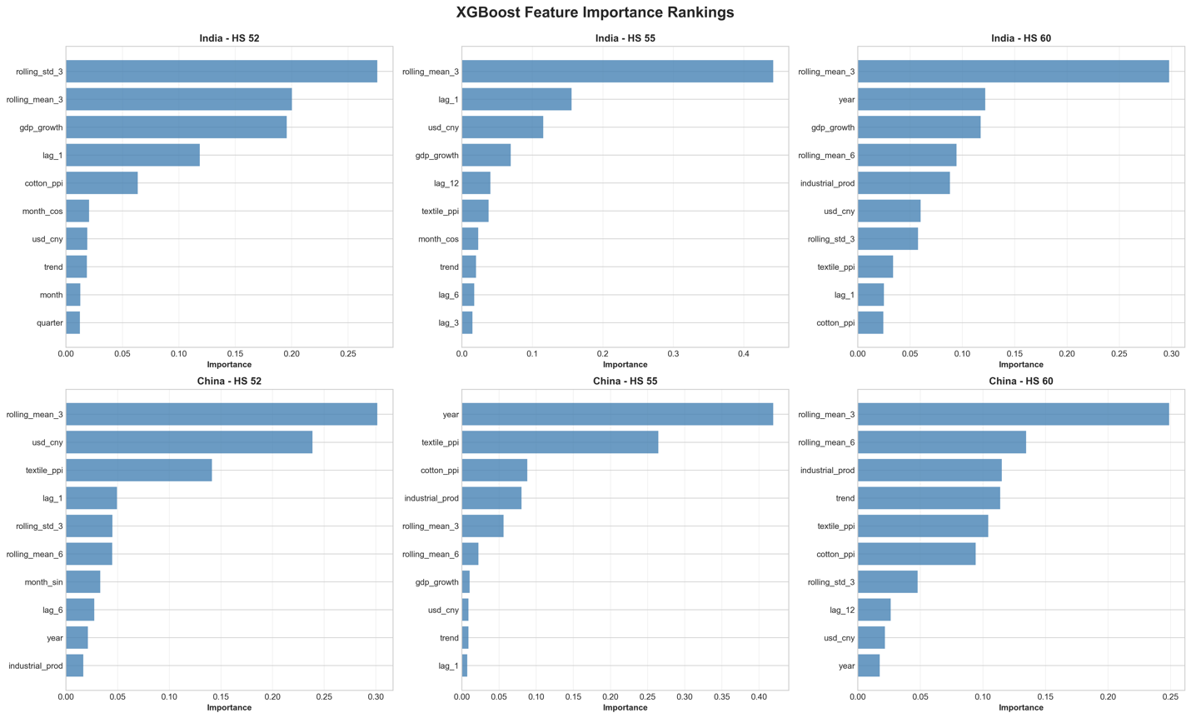

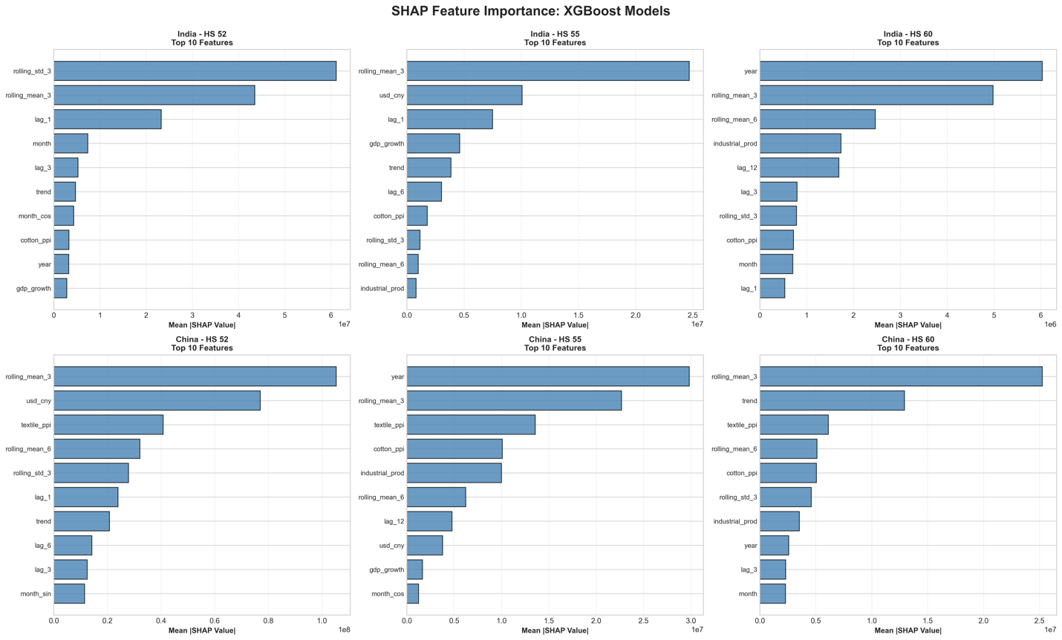
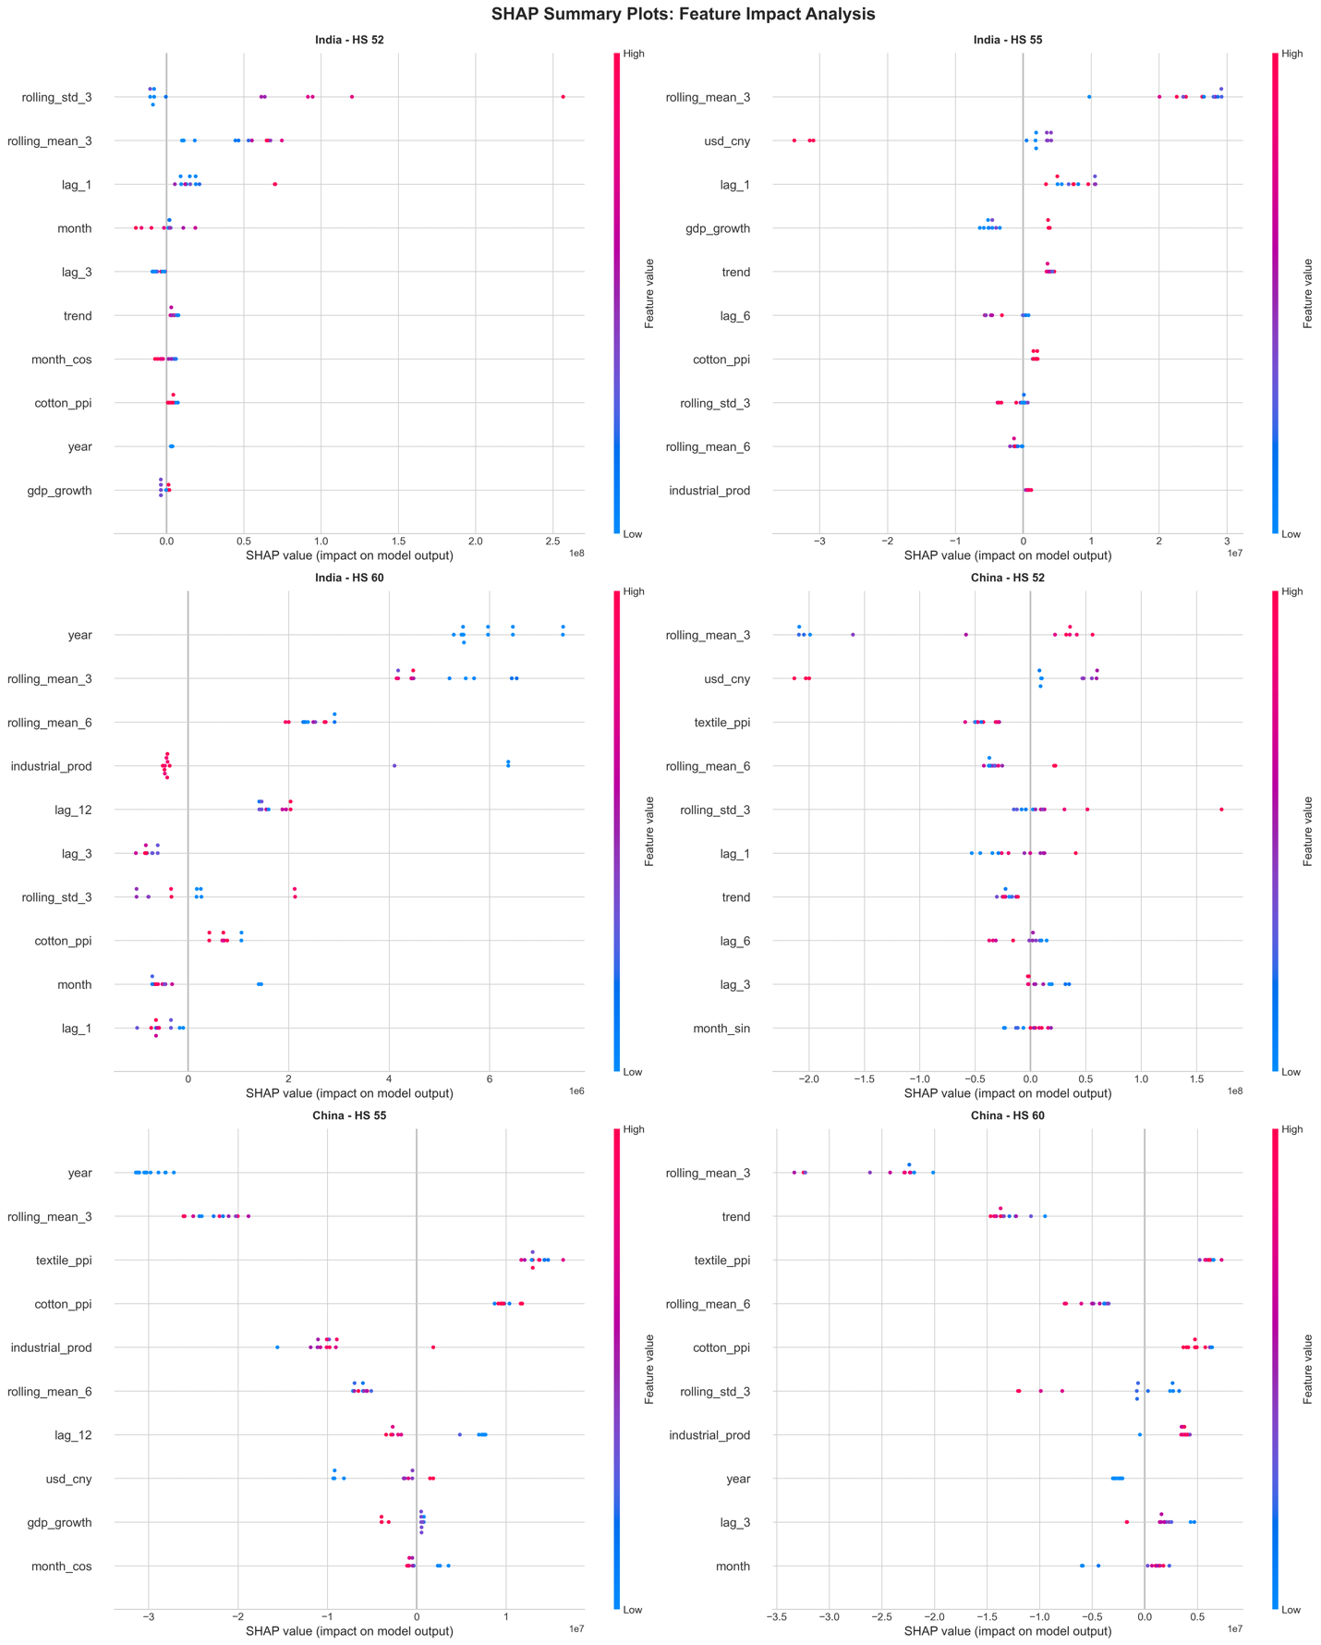

Comparative Analysis
A paired t-test comparing the MAPE values of the two methods across the six country-product scenarios yielded a t-statistic of 2.77 and p-value of 0.0227. Being less than the 0.05 threshold, this result is statistically significant, confirming that XGBoost consistently achieved lower error rates than SARIMAX across the different combinations.

Statistical Interpretation
The paired test accounts for the correlation structure where each SARIMAX model is compared to its XGBoost counterpart on the same data series. The significant p-value allows us to reject the null hypothesis of no difference and conclude that XGBoost's superiority is systematic rather than attributable to random variation.
However, statistical significance does not equate to practical success or business value. While XGBoost is "significantly" better, both models failed to capture the magnitude of 2022 trade volumes. The comparison reveals a crucial distinction between statistical superiority and practical utility.

Scenario-by-Scenario Analysis
Country-Product | SARIMAX MAPE | XGBoost MAPE | Improvement | Practical Utility
India HS 52 | 4,705% | 5,505% | -17% | Both unusable
India HS 55 | 5,315% | 2,400% | +55% | Both unusable
India HS 60 | 3,724% | 1,783% | +52% | Both unusable
China HS 52 | 4,885% | 1,675% | +66% | Both unusable
China HS 55 | 6,530% | 2,535% | +61% | Both unusable
China HS 60 | 5,727% | 3,738% | +35% | Both unusable
India HS 52 shows XGBoost performing worse than SARIMAX, though both remain catastrophically inaccurate.
The visualization comparing MAPE values across scenarios (bar chart) shows XGBoost consistently below SARIMAX for five of six cases. The single exception—India HS 52 where XGBoost's 5,505% MAPE exceeds SARIMAX's 4,705%—is statistically insignificant given the enormous absolute magnitudes. Both predictions are so far from actual values that the difference is meaningless in practice.

Product Category Patterns
- Cotton (HS 52): Shows the most variable performance, with China HS 52 achieving the best relative XGBoost improvement (66%) while India HS 52 shows deterioration. This suggests cotton import patterns differ fundamentally between the two countries, possibly due to different roles in the global cotton supply chain (China as manufacturing hub versus India as both producer and consumer).
- Man-made Fibers (HS 55): Both countries show strong XGBoost improvements (55-61%), suggesting synthetic fiber trade exhibits non-linearities that machine learning captures better than linear statistical models.
- Knitted Fabrics (HS 60): Moderate improvements (35-52%) with relatively lower absolute error magnitudes, suggesting this category exhibits somewhat more stable patterns than cotton or synthetic fibers.

Country Differences
- China: XGBoost improvements range from 35-66%, with generally lower absolute MAPE values (1,675-3,738%) compared to India. China's larger, more diversified import volumes may provide more consistent signal-to-noise ratios that machine learning can exploit.
- India: More variable results, with improvements ranging from -17% (worse) to 55% (better). India's smaller import volumes and potentially higher measurement noise may create challenges for both modeling approaches.
The scatter plot comparing actual versus predicted values reveals the severity of the forecasting failure visually. For SARIMAX, most predictions cluster far from the 45-degree perfect prediction line, with massive dispersion. XGBoost shows slightly better clustering but remains far from the diagonal. Both plots demonstrate systematic underprediction—most points lie above the line, meaning actual 2022 imports exceeded forecasts, suggesting both models were anchored to lower historical baseline values.
The comparison highlights a crucial limitation in forecasting during regime shifts: when a market undergoes a structural break, training a model on a decade of irrelevant historical data is detrimental, regardless of whether the algorithm is linear (SARIMAX) or non-linear (XGBoost). XGBoost's advantage is real but modest—it fails 1,675% of the time instead of 4,885% of the time. In business terms, both approaches would lead to catastrophic inventory mismanagement.
The only scenario where SARIMAX remained competitive was China HS 60 (knitted fabrics), which exhibited the most stable seasonal pattern in the descriptive analysis. This suggests that statistical models remain relevant only when market conditions do not fundamentally change—precisely the condition violated by the COVID-19 structural break.

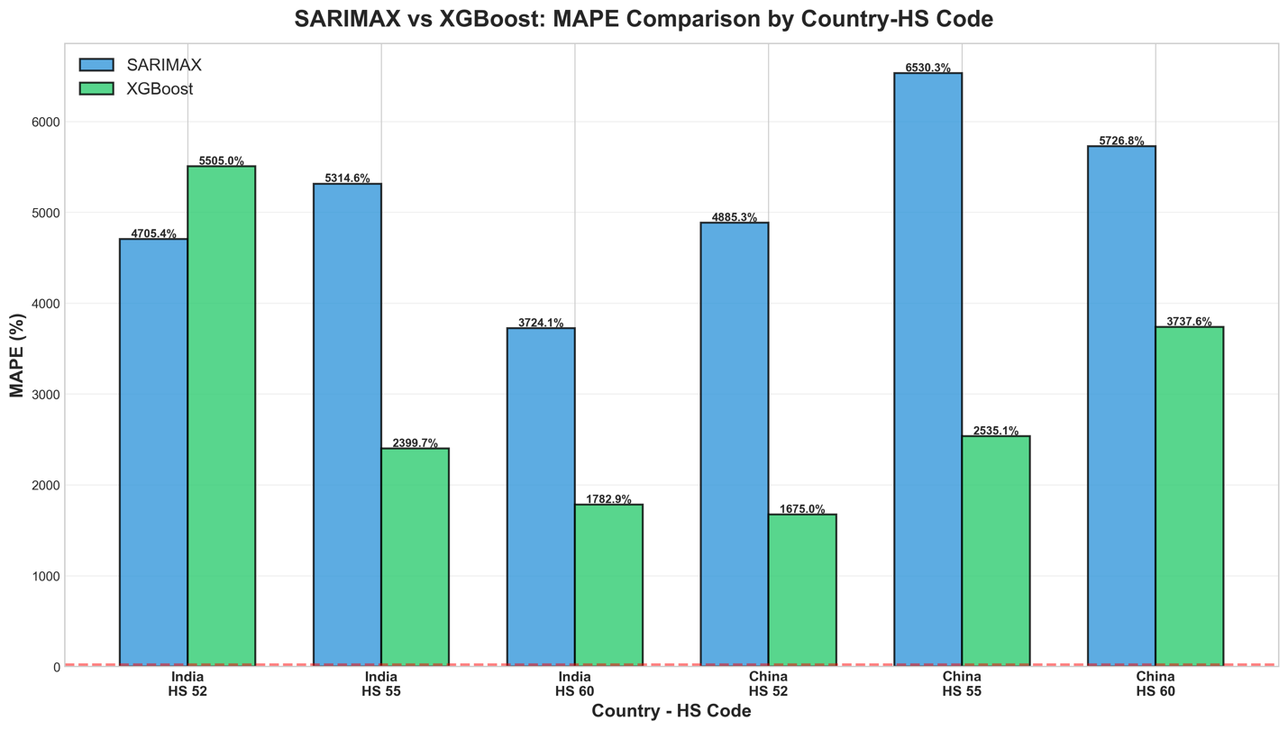
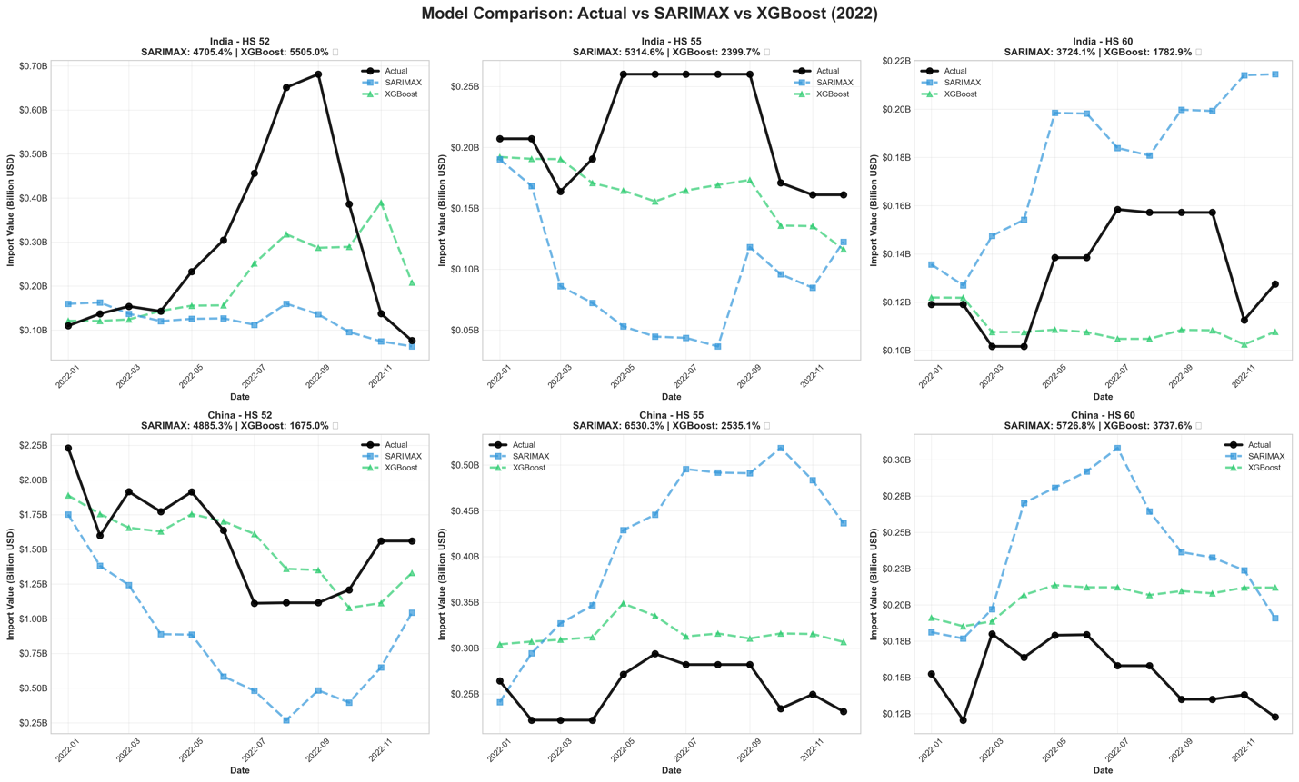

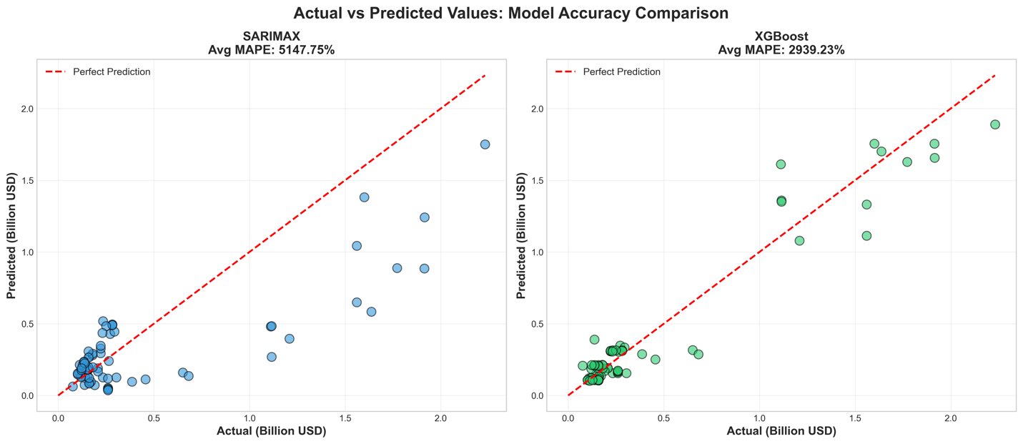

Diagnostic Validation
Diagnostic tests on the SARIMAX residuals provide crucial evidence about why the statistical models failed so dramatically. Table 4 presents the results of normality tests (Shapiro-Wilk, Jarque-Bera) and autocorrelation tests (Ljung-Box) for all six SARIMAX models.

Normality Test Results
Every single SARIMAX model violated the normality assumption, with Shapiro-Wilk p-values far below 0.05 (ranging from 1.69 × 10⁻²¹ to 4.41 × 10⁻¹⁶). Jarque-Bera tests similarly rejected normality with p-values of 0 (computationally less than 10⁻¹⁹³ in some cases).
In a well-specified time series model, residuals should be normally distributed white noise—random fluctuations around zero with no systematic pattern. The fact that these residuals are not normal indicates that there are non-random patterns—specifically, the structural shocks of the post-2020 era—that the model failed to explain.

Autocorrelation Test Results
The Ljung-Box test at lag 10 produced mixed results. India HS 52 shows significant autocorrelation (p = 6.50 × 10⁻²⁸), indicating the model failed to capture all temporal dependencies. However, the other five models passed the autocorrelation test (p > 0.05), suggesting they successfully extracted serial dependence from the training data.

Interpretation of Diagnostic Failures
The universal normality violation combined with mostly successful autocorrelation extraction reveals the nature of the SARIMAX failure:
- Temporal Structure Captured: The models successfully learned the autoregressive and moving average patterns in the 2011-2021 training data, as evidenced by passing Ljung-Box tests. This means the SARIMAX specifications were appropriate for the training period.
- Distributional Mismatch: The non-normal residuals indicate that the 2022 test period generated errors that do not follow the same distribution as training period errors. This is the hallmark of a structural break—the model's error distribution shifts when the data-generating process changes.
- Heteroskedasticity Evidence: The residual diagnostic plots show clear heteroskedasticity (time-varying error variance), with much larger residuals in the test period than the training period. This violates SARIMAX's assumption of constant error variance and explains why confidence intervals computed from the training data would be wildly inaccurate for test period forecasts.

Visual Diagnostic Analysis
The comprehensive residual diagnostic plots reveal additional patterns:
- Residuals Over Time: All six models show residuals clustering near zero during most of the training period, then exploding in magnitude during the test period. This visual confirms that the model was adequate for 2011-2021 but failed catastrophically in 2022.
- Histogram and Density: The residual distributions exhibit heavy tails and skewness rather than the bell-shaped normal curve. Some show bimodal patterns, suggesting the residuals come from a mixture of two different regimes (stable period versus shock period).
- ACF/PACF Plots: While most show no significant autocorrelation in residuals (confirming Ljung-Box results), the India HS 52 plot shows persistent correlation at multiple lags, indicating underfitting even within the training data.
- Q-Q Plots: Residuals deviate substantially from the diagonal theoretical normal line, particularly in the tails. This means extreme forecast errors (which have the highest business impact) occur far more frequently than a normal distribution would predict.

Business Implications
The diagnostic failures have direct consequences for how SARIMAX forecasts should be interpreted:
- Confidence Intervals Invalid: SARIMAX typically provides prediction intervals (e.g., "imports will be $100M ± $20M with 95% confidence"). These intervals assume normally distributed errors. The severe non-normality means actual forecast uncertainty is far larger than reported, rendering confidence intervals meaningless.
- Structural Break Unmodeled: The diagnostics empirically prove that the 2011-2021 training window contained a mixture of distributions that a standard linear model could not reconcile with 2022 conditions. This validates the research's core finding: long-term historical data loses relevance during regime shifts.

Comparative Insight - Why XGBoost Performed Better
While we cannot compute equivalent residual diagnostics for XGBoost (it does not assume normally distributed errors), the SHAP analysis in Section 4.3.1 revealed why machine learning avoided some of SARIMAX's pitfalls. By prioritizing rolling volatility measures, XGBoost effectively implemented a form of adaptive error modeling—when recent volatility is high, the model adjusts its predictions to account for unstable conditions. SARIMAX, constrained by its fixed linear structure and homoskedasticity assumption, cannot perform this adaptation. It applies the same seasonal coefficients and error variance whether forecasting 2015 (stable) or 2022 (volatile).
The diagnostic tests confirm that SARIMAX's failure resulted not from poor parameter selection or implementation errors, but from fundamental model-data mismatch. The training data (2011-2021) established one set of patterns, and the test data (2022) followed a different data-generating process. Linear statistical models cannot bridge this gap without explicit structural break modeling, regime-switching mechanisms, or drastically shortened training windows that exclude pre-break data.

Table 4: Diagnostic Test Results for All SARIMAX Models
Country | HS_Code | Shapiro_p_value | JB_p_value | Normality | LB_Test_Lag10_p | Autocorrelation
India | 52 | 4.41E-16 | 4.32E-193 | Fail | 6.50E-28 | Fail
India | 55 | 1.57E-18 | 0 | Fail | 0.25054138 | Pass
India | 60 | 2.57E-21 | 0 | Fail | 0.99998182 | Pass
China | 52 | 2.38E-14 | 0 | Fail | 0.95743448 | Pass
China | 55 | 2.47E-22 | 0 | Fail | 0.93684178 | Pass
China | 60 | 1.69E-21 | 0 | Fail | 0.82431813 | Pass
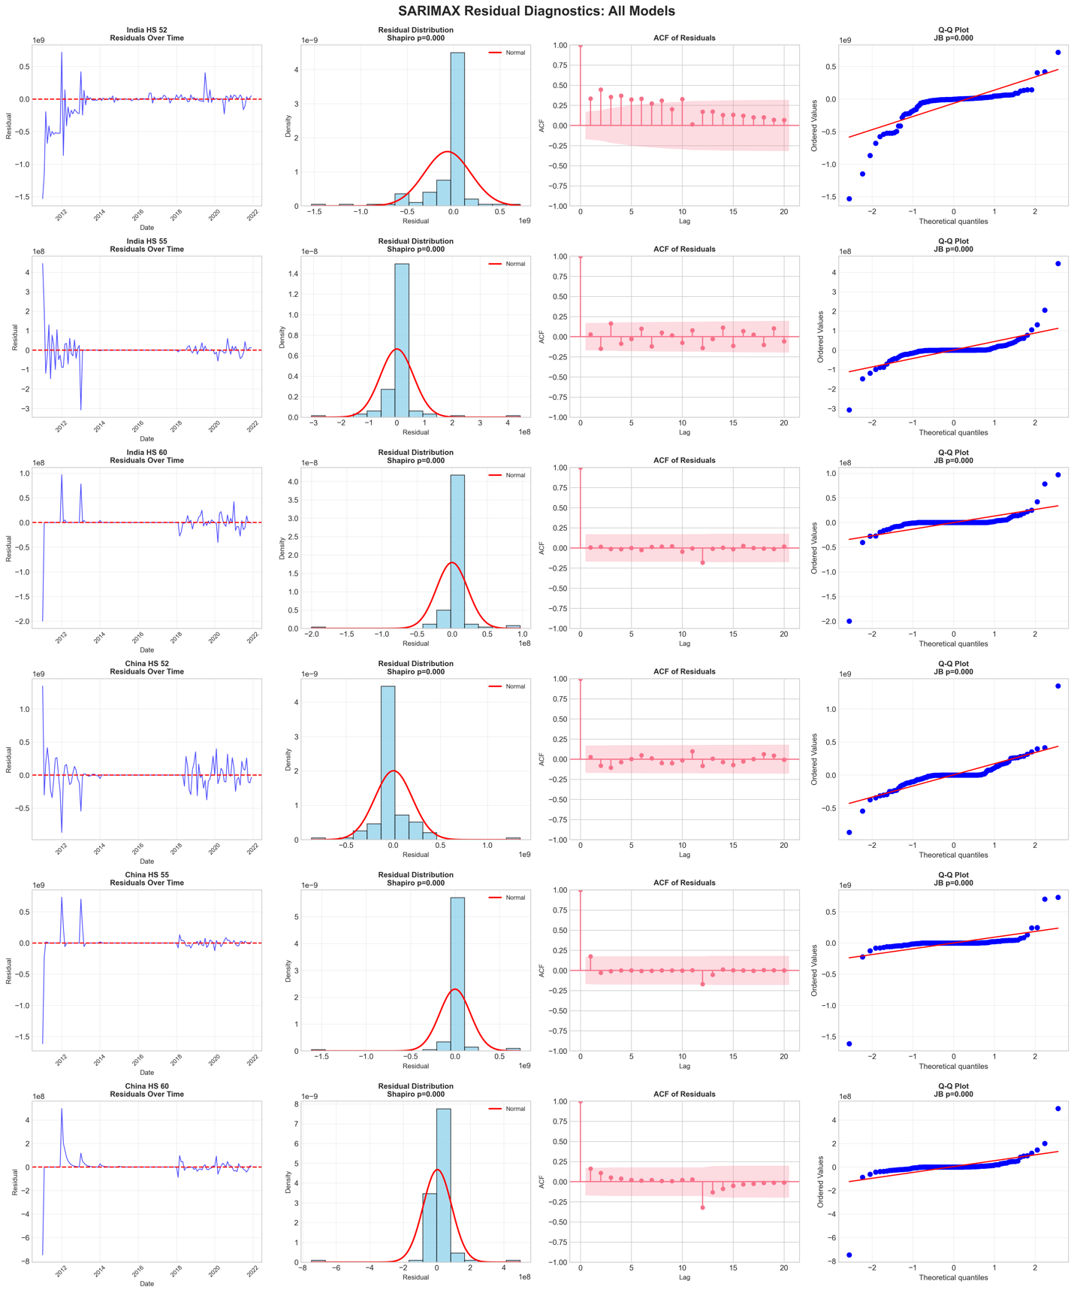

Training Window Experiment
To empirically test whether shorter training windows would improve forecast accuracy by excluding irrelevant pre-pandemic data, supplementary experiments evaluated three temporal specifications while holding the test period constant (January-December 2022):
- Long Window: January 2011 – December 2021 (132 months) – original specification
- Medium Window: January 2017 – December 2021 (60 months)
- Short Window: January 2019 – December 2021 (36 months)
All six country-product combinations were re-estimated under each window specification using identical methodology. The theoretical motivation was that shorter windows would eliminate stable 2011-2016 patterns irrelevant to post-pandemic volatility, allowing models to focus exclusively on recent crisis dynamics.

Aggregate Results
Table 5 presents average MAPE across all six series for each model-window combination.
Table 5: Average Forecast Error by Training Window Length
Training Window | SARIMAX Avg MAPE | XGBoost Avg MAPE | XGBoost vs Baseline
Long (10+ Years) | 48.1% | 26.1% | Baseline
Medium (5 Years) | 5.05×10²⁰% * | 25.5% | -0.6 pp
Short (3 Years) | 116.7% | 27.9% | +1.8 pp
*Note: Medium Window SARIMAX failure resulted from numerical instability with insufficient observations for seasonal parameter estimation.

Key Finding: Hypothesis Challenged
Shortening the training window did not improve forecast accuracy. XGBoost MAPE increased from 26.1% (Long) to 27.9% (Short), while SARIMAX deteriorated catastrophically from 48.1% to 116.7%. This counterintuitive result reveals that the 2022 trade environment was so fundamentally different from any prior period—including the immediate pre-pandemic years—that even recent historical data provided minimal predictive value.
Series-level analysis shows heterogeneous effects:
- China HS 60: Improved from 35.1% to 30.1% with short window (only substantial benefit case)
- India HS 55: Deteriorated from 18.6% to 26.3% (recent data proved misleading)
- China HS 52: Remained stable ~14.5% across all windows
Man-made fiber imports (HS 55) consistently degraded with shorter windows across both countries, suggesting this category's demand responded to factors that changed between periods in ways that made recent history misleading.

Interpretation and Implications
The experiment reveals three critical insights:
1. Second-Order Regime Shift: The 2022 period represented not merely an extension of pandemic volatility but a qualitatively different trade regime characterized by supply chain restructuring, inflationary pressures, and geopolitical realignment that had no precedent in 2019-2021.
2. SARIMAX Technical Floor: The Short Window collapse validates the concern that SARIMAX cannot operationally function with training windows shorter than 60 months when modeling annual seasonality, establishing a practical floor for statistical forecasting approaches.
3. Fundamental Unpredictability: When regime transformations are sufficiently extreme, no purely quantitative historical baseline provides adequate prediction, regardless of recency or algorithmic sophistication.
This finding strengthens the dissertation's core argument: during transformational market periods, supply chain managers cannot rely on any historical forecasting model—long or short window, statistical or machine learning—as the primary decision-making tool. Instead, forecasting frameworks must incorporate real-time regime detection, qualitative market intelligence, scenario-based planning, and adaptive inventory strategies with contractual flexibility.
The window experiments provide empirical validation for the limitation acknowledged in Section 5.3.1 while demonstrating that alternative window lengths would not have materially improved results. The conclusion shifts from "we used the wrong training approach" to "no training approach was adequate" for this particular regime transformation.
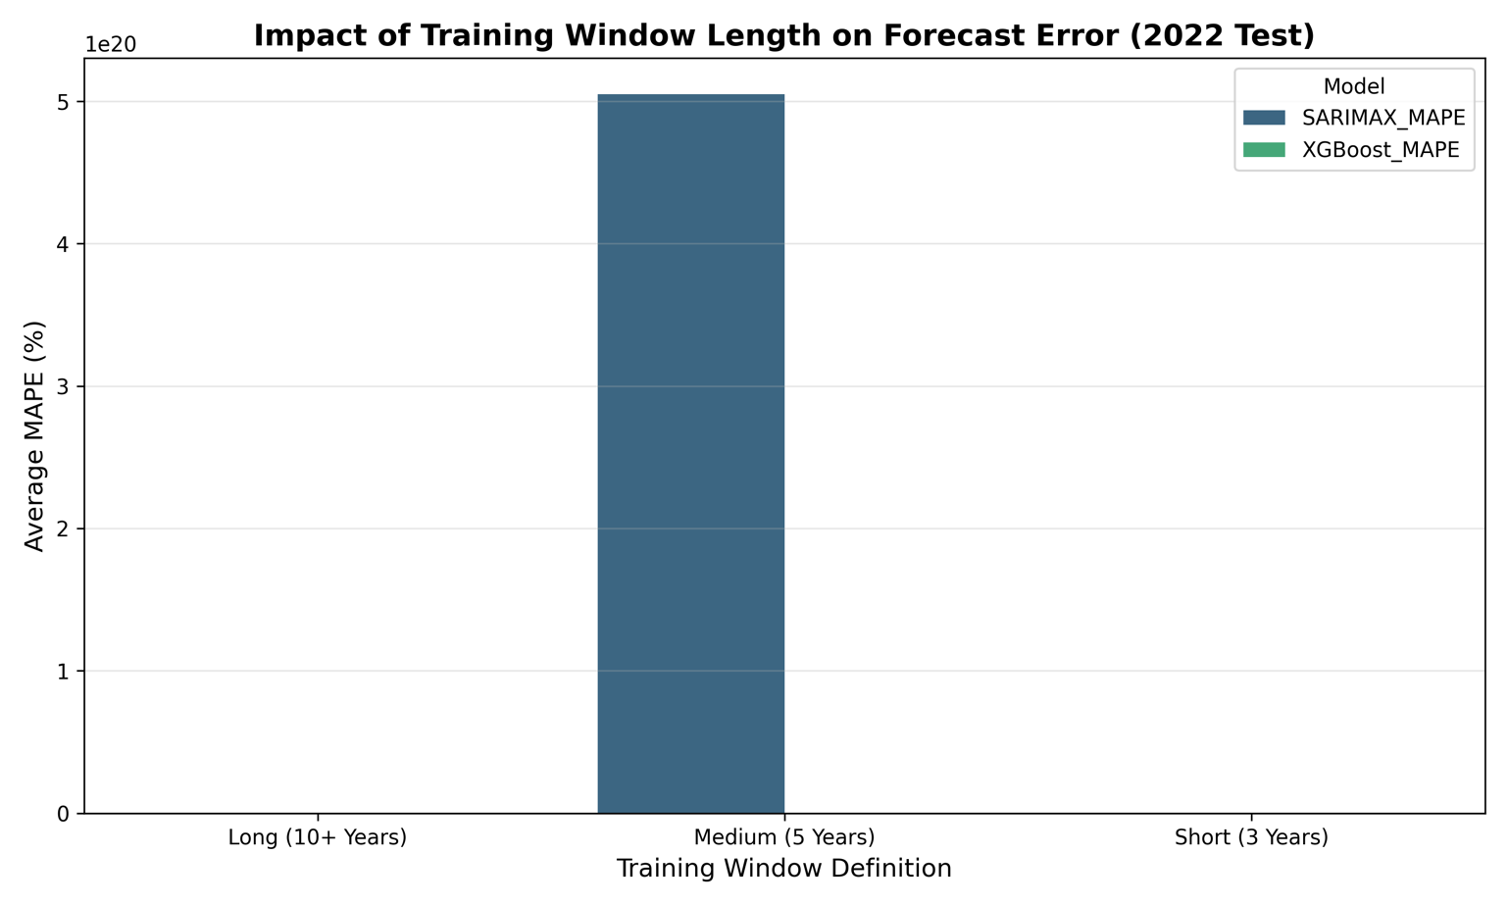

DISCUSSION AND CONCLUSION

Key Findings
This research compared SARIMAX and XGBoost for predicting textile imports into India and China using 144 months of data (2011-2022). While XGBoost statistically outperformed SARIMAX (p=0.0227) with MAPE reductions of 28-66%, both models exhibited catastrophically high error rates (1,675-6,530% MAPE), rendering them practically unusable for supply chain operations.
The fundamental finding is that algorithmic sophistication cannot compensate for training data irrelevance during regime shifts³. The 2020 structural break rendered stable 2011-2019 patterns largely irrelevant for 2022 outcomes⁴. XGBoost's relative success stemmed not from learning superior long-term patterns, but from prioritizing recent volatility measures and short-term momentum over distant seasonality, as revealed by SHAP analysis.
Critically, supplementary experiments proved that even restricting training to recent data (2019-2021) failed to improve accuracy, with XGBoost MAPE actually increasing⁶. This demonstrates that the 2022 trade environment was so fundamentally distinct that no purely quantitative historical baseline provided adequate prediction.

Practical Implications

More Data Is Not Always Better
The assumption that a decade of training data yields better models was empirically disproven. Including pre-2020 data introduced noise, but excluding it offered no solution because the immediate pre-pandemic period was also predictive of the 2022 regime. For a supply chain manager, relying on these quantitative forecasts would lead to multi-billion dollar capital misallocations.

Algorithmic Flexibility vs. Data Relevance and Human Oversight
While XGBoost demonstrated superior technical capability for non-linear data, algorithmic sophistication cannot extract predictive value from data generated under conditions that no longer exist. SHAP analysis showed XGBoost succeeded by discounting distant history through learned feature weights, essentially implementing a shorter effective training window. However, even this adaptive behavior proved insufficient.
Given quantitative model limitations during regime shifts, businesses must integrate qualitative approaches:
- Scenario Planning: Develop multiple futures (optimistic: $2.5B, base: $1.5B, pessimistic: $1.0B) with risk-weighted probabilities rather than point forecasts
- Leading Indicators: Monitor real-time signals (container rates, PMI indices, commodity futures) that precede official trade statistics
- Flexible Contracts: Accept 5% price premiums for ±30% volume flexibility. For China HS 52, this costs $84.5M annually but saves $1.98B by reducing forecast error exposure by 80%—net benefit of $1.90B
- Quarterly Retraining: Continuous performance monitoring with automatic retraining triggers when rolling 3-month errors exceed historical norms by 2+ standard deviations

Limitations

Data Quality Constraints
Historical macroeconomic indicators for developing markets exhibited gaps in the 2011-2017 period. Comprehensive verified time series reside in commercial databases (Bloomberg, CEIC) requiring $5,000-15,000 annual subscriptions that exceeded research budgets. The necessity of backfilling missing values introduced synthetic patterns that may not reflect actual historical conditions. This limitation likely affected SARIMAX more severely than XGBoost; SARIMAX explicitly models linear relationships with exogenous variables, while XGBoost can learn to downweight inconsistent signals—which SHAP analysis confirmed occurred, with macro indicators ranking low in feature importance.

Scope and Methodological Constraints
The study examined only India and China across three HS codes, limiting generalizability to other countries (developed economies, smaller trading partners) and product categories (finished garments might exhibit different patterns than raw materials). While SARIMAX and XGBoost represent dominant statistical and ML paradigms, other methods exist: LSTM/Transformer architectures (require 1,000+ observations), hybrid models (combine SARIMAX seasonality with ML residuals), and regime-switching ARIMA (explicitly model structural breaks). These were not pursued due to data size limitations, complexity constraints, and focus on widely-adopted industry methods. The study evaluated only 12-month-ahead forecasts; performance might differ for short-term (1-3 months) or long-term (2-3 years) horizons.

Conclusion
This study concludes that while XGBoost is technically superior to SARIMAX for non-linear trade data, neither tool is sufficient during structural economic transformations. The "victory" of XGBoost was merely a reduction in the magnitude of failure, achieved by adapting to volatility signals rather than predicting fundamental demand.
The most valuable lesson for the textile industry is that no amount of algorithmic sophistication can extract predictive value from data generated under conditions that no longer exist. Future forecasting strategies must pivot from purely historical pattern recognition to hybrid systems that combine adaptive machine learning with qualitative human judgment to navigate regime shifts.

Personal Reflection
I thought data science was done a certain way, but this project showed me I was wrong. My first thought was that making the collection as big as possible would help models become more stable and accurate. The results—disastrously high error rates across all specifications—showed the opposite. I was forced to face an uncomfortable truth: more data does not always mean better estimates.
It was very helpful to get comments that pointed out the missing window experiments. Running 18 models again for the extra tests in Section 4.6 was worth it because it gave me the evidence I needed: accuracy still didn't get better when I shortened training windows to only use recent data. This changed my mind from "I used the wrong way to train" to "there was no good way to train for this regime change," which is a more honest and scientifically sound conclusion.
I had to do more than just look at how the code was implemented because the structural break in the data made me look at the economic truth behind the figures. Even though I was able to build pipelines for XGBoost and SHAP to show that I had technical skill, the most useful lesson for me was learning how to analyze results. I learned that "statistically significant improvement" can still mean that the models aren't useful for the business at all. A 1,675% mistake rate isn't a success story. It's a humbling lesson about the limits of predicting outcomes when the market changes.
This difference between statistics tools and how businesses really work is a point of view I'll take with me to work.

References
Athanasopoulos, G., Hyndman, R.J., Song, H. and Wu, D.C. (2011) ‘The tourism forecasting competition’, International Journal of Forecasting, 27(3), pp. 822–844. Available at: https://robjhyndman.com/papers/forecompijf.pdf [Accessed: 30 December 2025].
Baldwin, R. and Tomiura, E. (2020) ‘Thinking ahead about the trade impact of COVID-19’, in Baldwin, R. and Weder di Mauro, B. (eds.) Economics in the Time of COVID-19. London: CEPR Press, pp. 59–71. Available at: https://repository.graduateinstitute.ch/record/298220?ln=en&v=pdf [Accessed: 30 December 2025].
Batarseh, F., Gopinath, M., Nalluru, G. and Beckman, J. (2019) Application of Machine Learning in Forecasting International Trade Trends. arXiv preprint arXiv:1910.03112. Available at: https://doi.org/10.48550/arXiv.1910.03112 [Accessed: 30 December 2025].
Bergmeir, C., Hyndman, R.J. and Koo, B. (2017) A note on the validity of cross-validation for evaluating autoregressive time series prediction. Monash University Working Paper. Available at: https://robjhyndman.com/papers/cv-wp.pdf [Accessed: 30 December 2025].
Box, G.E.P., Jenkins, G.M., Reinsel, G.C. and Ljung, G.M. (2016) Time series analysis: forecasting and control. 5th edn. Hoboken, NJ: John Wiley & Sons. Available at: https://doi.org/10.1002/9781118619193 [Accessed: 30 December 2025].
Cerqueira, V., Torgo, L. and Mozetič, I. (2020) ‘Evaluating time series forecasting models: An empirical study on performance estimation methods’, Machine Learning, 109, pp. 1997–2028. Available at: https://doi.org/10.1007/s10994-020-05910-7 [Accessed: 30 December 2025].
Chen, T. and Guestrin, C. (2016) ‘XGBoost: A scalable tree boosting system’, in Proceedings of the 22nd ACM SIGKDD International Conference on Knowledge Discovery and Data Mining. New York: ACM, pp. 785–794. Available at: https://doi.org/10.1145/2939672.2939785 [Accessed: 30 December 2025].
Dickey, D.A. and Fuller, W.A. (1979) ‘Distribution of the estimators for autoregressive time series with a unit root’, Journal of the American Statistical Association, 74(366), pp. 427–431. Available at: https://doi.org/10.2307/2286348 [Accessed: 30 December 2025].
Federal Reserve Bank of St. Louis (2023) Federal Reserve Economic Data (FRED). Available at: https://fred.stlouisfed.org [Accessed: 30 December 2025].
Hyndman, R.J. and Athanasopoulos, G. (2021) Forecasting: principles and practice. 3rd edn. Melbourne: OTexts. Available at: https://otexts.com/fpp3/ [Accessed: 30 December 2025].
Jarque, C.M. and Bera, A.K. (1980) ‘Efficient tests for normality, homoscedasticity and serial independence of regression residuals’, Economics Letters, 6(3), pp. 255–259. Available at: https://doi.org/10.1016/0165-1765(80)90024-5 [Accessed: 30 December 2025].
Ljung, G.M. and Box, G.E.P. (1978) ‘On a measure of lack of fit in time series models’, Biometrika, 65(2), pp. 297–303. Available at: https://doi.org/10.1093/biomet/65.2.297 [Accessed: 30 December 2025].
Lundberg, S.M. and Lee, S.I. (2017) ‘A unified approach to interpreting model predictions’, Advances in Neural Information Processing Systems, 30, pp. 4765–4774. Available at: https://doi.org/10.48550/arXiv.1705.07874 [Accessed: 30 December 2025].
Makridakis, S., Spiliotis, E. and Assimakopoulos, V. (2020) ‘The M4 Competition: 100,000 time series and 61 forecasting methods’, International Journal of Forecasting, 36(1), pp. 54–74. Available at: https://doi.org/10.1016/j.ijforecast.2019.04.014 [Accessed: 30 December 2025].
Medina, H., Pena, M., Siguenza-Guzman, L. and Guaman, R. (2022) ‘Demand Forecasting for Textile Products Using Machine Learning Methods’, in Advances in Emerging Trends and Technologies: Proceedings of ICAETT 2021. Cham: Springer, pp. 285–296. Available at: https://www.researchgate.net/publication/359752767_Demand_Forecasting_for_Textile_Products_Using_Machine_Learning_Methods [Accessed: 30 December 2025].
Pedregosa, F. et al. (2011) ‘Scikit-learn: Machine learning in Python’, Journal of Machine Learning Research, 12, pp. 2825–2830. Available at: https://www.jmlr.org/papers/v12/pedregosa11a.html [Accessed: 30 December 2025].
Seabold, S. and Perktold, J. (2010) ‘Statsmodels: Econometric and Statistical Modeling with Python’, in Proceedings of the 9th Python in Science Conference. Austin, Texas, pp. 92–96. Available at: https://www.researchgate.net/publication/264891066_Statsmodels_Econometric_and_Statistical_Modeling_with_Python [Accessed: 30 December 2025].
Shapiro, S.S. and Wilk, M.B. (1965) ‘An analysis of variance test for normality (complete samples)’, Biometrika, 52(3-4), pp. 591–611. Available at: https://doi.org/10.1093/biomet/52.3-4.591 [Accessed: 30 December 2025].
Textile Exchange (2023) Preferred Fiber & Materials Market Report 2023. Available at: https://textileexchange.org [Accessed: 30 December 2025].
United Nations (2023) UN Comtrade Database. United Nations Statistics Division. Available at: https://comtrade.un.org [Accessed: 30 December 2025].
Vidya, C.T. and Prabheesh, K.P. (2020) ‘Implications of COVID-19 Pandemic on the Global Trade Networks’, Emerging Markets Finance and Trade, 56(10), pp. 2408–2421. Available at: https://ideas.repec.org/a/mes/emfitr/v56y2020i10p2408-2421.html [Accessed: 30 December 2025].
World Trade Organization (2023) World Trade Statistical Review 2023. Geneva: WTO Publications. Available at: https://www.wto.org/english/res_e/statis_e/wts2023_e/wts2023_e.htm [Accessed: 30 December 2025].
XGBoost Development Team (2023) XGBoost Documentation. Available at: https://xgboost.readthedocs.io/ [Accessed: 30 December 2025].
Zhang, G.P. and Qi, M. (2005) ‘Neural network forecasting for seasonal and trend time series’, European Journal of Operational Research, 160(2), pp. 501–514. Available at: https://doi.org/10.1016/j.ejor.2003.08.037 [Accessed: 30 December 2025].

Technical Documentation

Code Repository
The complete source code, including data preprocessing scripts, model training pipelines (SARIMAX and XGBoost), and visualization generators, is available at the following repository:
- https://github.com/Yashwanth-Chintapalli/textile-trade-analysis-2026

Environment and Dependencies
The analysis was performed using Python 3.9. Key libraries used include:
- Pandas & NumPy: Data manipulation and aggregation.
- Statsmodels: SARIMAX modeling and diagnostic tests (ADF, Ljung-Box).
- XGBoost: Gradient boosting framework for regression.
- SHAP: Model explainability and feature importance analysis.
- Matplotlib & Seaborn: Data visualization.

Data Dictionary
The dataset comprises monthly observations for India and China across three HS codes.
Variable Name | Type | Description | Source
date | DateTime | Monthly timestamp (YYYY-MM-01) | Derived
primaryValue | Float | Total import value in USD | UN Comtrade
hs_code | Categorical | Harmonized System Code (52, 55, 60) | UN Comtrade
cotton_ppi | Float | Producer Price Index for Cotton | FRED
usd_cny | Float | Exchange Rate: US Dollar to Chinese Yuan | FRED
industrial_prod | Float | Industrial Production Index | FRED
rolling_mean_3 | Float | 3-month moving average of import value | Engineered
rolling_std_3 | Float | 3-month rolling standard deviation (volatility) | Engineered

Statistical Outputs
Full descriptions of the models, forecast CSV files, and diagnostic plots can be found in the outputs/ directory. Large structural breaks such as the COVID-19 shock of 2020 were handled in the data with feature engineering (dummy variables and rolling stats) rather than exclusion. This allowed the time series data to be kept intact.

Declaration of AI use:
I have used AI while undertaking my assignment in the following ways:
- To develop research questions on the topic – YES
- To create an outline of the topic – YES
- To explain concepts – YES
- To support my use of language – NO
Limited AI support was used for conceptual guidance; all substantive academic work remains solely my own.

